Oral & Maxillofacial Radiology

Syndromes/Systemic 2

Cherubism 2

Nevoid Basal Cell Carcinoma Syndrome (NBCCS) 3

Fibro-Osseous Lesions 4

Fibrous Dysplasia 4

Ossifying Fibroma 5

Osseous Dysplasia 6

Odontoma 8

Other Radiopaque Lesions of the Jaws 9

Antral Pseudocyst 9

Cementoblastoma 10

Sclerosing Osteitis/Condensing Osteitis 11

Dense Bone Island (DBI) 11

Radiolucent Lesions of the Jaws 12

Lateral Periodontal Cyst 12

Dentigerous Cyst 13

Keratocystic Odontogenic Tumor (KCOT) 14

Ameloblastoma 15

Odontogenic Myxoma 16

Nasopalatine Duct Cyst 17

Pseudocysts 18

Simple Bone Cyst (Traumatic Bone Cyst) 18

Lingual Bone Defect (Stafne Defect) 19

Periapical Radiolucency of Inflammatory Origin (PRIO) 19

Various Radiographs 20

Differential Diagnosis Flowcharts 26

A Very Large Table 47

# Syndromes/Systemic

## Cherubism

= Rare Autosomal Dominant condition

|  |  |
| --- | --- |
| **Clinical Features** | * Develops in early childhood * Bilateral expansion/swalling of the cheeks * “Heavenly Gaze” * Self Resolves around time of skeletal maturity |
| **Radiographic Features** | |  |  | | --- | --- | | **Site** | Bilateral and affects both the maxilla and mandible   * Always in the posterior body and ramus of mandible and the tuberosity of the maxilla | | **Shape** | Well defined, corticated multiple lesions | | **Size** |  | | **Shade** | RL with a multilocular pattern and internal septae | | **Surroundings** | Significant bony expansion with substantial displacement of the medial and lateral surfaces of the ramus   * Medial displacement may block the airway   Adjacent teeth   * Destroys developing tooth buds * Significant tooth displacement (towards the midline usually) | | **Density** |  | | **Displacement** | Displacement of the Maxillary sinus floor | | **Diameter** |  | |
| **Differential Dx** |  |
| **Tx** | Delay Tx until the lesions stop growing |

## Nevoid Basal Cell Carcinoma Syndrome (NBCCS)

= AKA Gorlin-Goltz Syndrome

|  |  |
| --- | --- |
| **Clinical Features** | Variable phenotypes including:   * Multiple Basal Cell Carcinoma of the skin, Palmar and planting pitting, Skeletal abnormalities (bifid ribs, vertebral fusion, polydactyly, temporoparietal bossing), Calcified Falx Cerebri. * Multiple KCOTs * BCC most frequent in North Europeans * Multiple KCOT most frequent in East Asians * Presents in 20-30s (10 years earlier than single KCOTs) |
| **Radiographic Features** | Nevoid Basal Cell Carcinoma Syndrome (NBCCS) | IntechOpenSee KCOT, and add a bunch of these in the mandible   |  |  | | --- | --- | | **Site** | Multiple lesions, mostly Posterior sextant of Mandible | | **Shape** | Well defined, corticated and scalloped border   * May be multilocular | | **Size** |  | | **Shade** | RL, might have internal Septa | | **Surroundings** | Grows M-D with minimal B-L expansion  Adjacent teeth   * May displace and resorb roots, but to a much lesser extent vs ameloblastoma | | **Density** |  | | **Displacement** |  | | **Diameter** |  | |
| **Differential Dx** |  |
| **Tx** |  |

# Fibro-Osseous Lesions

**(Fibrous Dysplasia, Ossifying Fibroma, Osseous Dysplasia, Odontoma)**

## Fibrous Dysplasia

- Symptomatic regional alteration of bone in which the normal architecture is replaced by fibrous tissue and nonfunctional trabeculae-like osseous structures; lesions may be monostotic or polyostotic, with or without associated endocrine disturbances.

|  |  |
| --- | --- |
| **Clinical Features** | Age: most often juveniles and young adults   * singular, slow-growing, painless swelling of either jaw   Location: more common in maxilla than mandible  overgrowth of tissue that occurs centrally in the jaws  may involve impacted or unerupted teeth  disfiguring, may present as facial enlargement of affected side  increased level of serum alkaline phosphatase  **Classification:**   * ***Monostotic*** (“craniofacial”): mandible or maxilla (not truly one bone); can cross sutures of maxilla, but cannot cross periosteum; if reaches posterior maxilla, cannot cross to pterygoid plate, instead just forces mandible forwards; usually diagnosed in 3rd decade; 85% of cases * ***Polyostotic***: systemic, involves multiple bones; usually diagnosed in childhood * McCune - Albright syndrome: polyostotic FD + precocious puberty * Jaffe syndrome |
| **Radiographic Features** | |  |  | | --- | --- | | **Site** | Maxilla 2x more than mandible  Posterior Regions of the jaws  ***Monostotic***: 1 Bone  ***Polyostotic***: >1 Bone | | **Shape** | Poorly Defined  Fusiform expansion | | **Size** |  | | **Shade** | Radiolucent with radiopaque features (granular ground glass, peau d’orange, fingerprint, cotton wool)   * Early lesions are more RL | | **Surroundings** | - Bone expansion as lesion grows   * Thinning of the cortex (but not complete erosion) * Displaces the borders of the sinus in the maxilla   - “Blurs” cortical boundaries of bone (Sinus floor, B/L plate, IAN walls) as the cortical bone becomes affected  - Adjacent teeth may be displaced. Root resorption is rare   * Lamina Dura may disappear around affected bone | | **Density** |  | | **Displacement** | Displaces Maxillary antrum floor, and may displace IAN canal superiorly if underneath it | | **Diameter** |  | |
| **Differential Dx** | Fibrous Dysplasia  Ossifying Fibroma |
| **Tx** | • Surgery for cosmetic or functional problems, but may increase lesion activity  • Typically self-limiting and regress in early adulthood  • Do not irradiate: can induce sarcomatous changes |

## Ossifying Fibroma

A well-demarcated, **encapsulated**, expansile intraosseous lesion of the jaws composed of cellular fibrous tissue containing spherical calcifications and irregular, randomly oriented bony structures.

|  |  |
| --- | --- |
| **Clinical Features** | * Slow growing neoplastic lesion * Asymptomatic * Females more than Males   Juvenile Ossifying Fibroma   * <15 years old * No Encapsulation * Very aggressive form |
| **Radiographic Features** | |  |  | | --- | --- | | **Site** | More often in the Mandible, apical to premolars and molars (superior to IAN canal)  When in Maxilla -> Canine fossa area | | **Shape** | Well Defined, encapsulated with a thin RL line   * cortex may appear thickened and sclerotic | | **Size** |  | | **Shade** | Mixed RL/RO -> Similar to Fibrous Dysplasia (ground glass, cotton-wool) | | **Surroundings** | Beach Ball expansion  Thinning (but still intact) of the cortical borders of the jaw  May resorb Teeth   * Lamina Dura is missing | | **Density** |  | | **Displacement** | May displace IAN and expand cortical plates  Displacement of Maxillary sinus floor  Displaces adjacent teeth | | **Diameter** |  | |
| **Differential Dx** | Fibrous Dysplasia  Osseous Dysplasia  Complex Odontoma |
| **Tx** | Surgical Enucleation + Curettage  Local Excision + Block Resection |

## Osseous Dysplasia

- Diffuse asymptomatic radiopaque and radiolucent intraosseous areas of osseous tissue that involve one or both arches.

Focal variant: a single lesion, affecting only 1 sextant/tooth

* Young Females of European origin

Florid variant: affecting more than 1 sextant

* Middle-old age female of East Asia or Subsaharan African extraction

Periapical Variant: Associated with Apex of mandibular anterior teeth

|  |  |
| --- | --- |
| **Clinical Features** | * Most frequent in African American Women * Usually painless with no external signs or symptoms |
| **Radiographic Features** | |  |  | | --- | --- | | **Site** | Periapical: Centered around root apex, may be multiple lesions   * Teeth are vital   Focal: Usually a solitary lesion in 1 sextant  Florid: Multiple, bilateral lesions present in Max and Mand | | **Shape** | Well defined border, variable shape | | **Size** |  | | **Shade** | RO center with variably wide RL rim. As lesions mature a band of thicker sclerotic bone might appear around the perifery | | **Surroundings** | Large lesions can cause expansion of bone B-L   * Thin intact cortex is present   Adjacent teeth:   * Lost Lamina Dura (PDL space either looks VERY wide, or not present) * No resorption though | | **Density** |  | | **Displacement** | May displace antrum floor  May displace IAN canal | | **Diameter** |  | |
| **Differential Dx** | Florid OD  Fibrous Dysplasia  Paget’s Disease  Ossifying Fibroma |
| **Tx** | * Not treated unless a secondary infection produces osteomyelitis |

## Odontoma

An usually hamartomatous lesion commonly found over unerupted teeth, containing enamel, dentin, pulp, and cementum in either recognizable tooth shapes (compound) or a solid gnarled mass (complex).

|  |  |
| --- | --- |
| **Clinical Features** | = Most common non-cystic odontogenic lesion   * Asymptomatic swelling * Most common in 1st and 2nd decade * May interfere with eruption of permanent teeth   Compound:   * Bag of Teeth * More common than complex   Complex:   * Strange tissue mass |
| **Radiographic Features** | |  |  | | --- | --- | | **Site** | More common in Maxilla vs Mandible   * Compound -> Anterior Maxilla * Complex -> Posterior Mandible | | **Shape** | Well Defined, smooth irregular periphery   * Corticated border | | **Size** |  | | **Shade** | Heterogenously RO -> More RO than ossifying fibroma   * Compound -> Toothlike structures * Complex -> irregular mass of calcified tissue | | **Surroundings** | Large lesions may expand bone -> Cortical boundary is maintained  Interferes with eruption of teeth   * Most associated with impacted or malposition tooth | | **Density** |  | | **Displacement** |  | | **Diameter** |  | |
| **Differential Dx** | Dense Bony Island -> Doesn’t have the RL Rim  Ossifying Fibroma -> Less RO and not associated with unerupted teeth  Osseous Dysplasia -> These are more associated with multiple tooth apices and are less RO |
| **Tx** | Simple Excision |

# Other Radiopaque Lesions of the Jaws

**(Antral Pseudocyst, Cementoblastoma, Dense Bone Island, Sclerosing Osteitis)**

## Antral Pseudocyst

* retention of fluid in the lining of the sinus

|  |  |
| --- | --- |
| **Clinical Features** | * More frequent in Caucasian |
| **Radiographic Features** | |  |  | | --- | --- | | **Site** | Maxillary Antrum of course | | **Shape** | Well defined Dome Shape   * Non-corticated and smooth   If Multiple -> Think Polyps   * Polys have thick mucosal lining | | **Size** |  | | **Shade** | Appears RO because it is projected over the airspace of the sinus, but it is still fluid filled | | **Surroundings** | No affect on surroundings  Adjacent teeth   * PDL is intact and normal   Polys can cause bony destruction and displacement | | **Density** |  | | **Displacement** |  | | **Diameter** |  | |
| **Differential Dx** | Antral Pseudocyst  Mucosal Polys |
| **Tx** | Usually leave the Pseudocyst |

## Cementoblastoma

A benign, well-circumscribed neoplasm of cementum-like tissue growing in continuity with the apical cemental layer of a molar or premolar that produce expansion of cortical plates and pain.

|  |  |
| --- | --- |
| **Clinical Features** | * Very rare * Pain on biting, Swelling, Expansion of cortical places * Continuous with the root * Pulp vitality is unrelated   Age:   * 2-6rd decade (before 25 though)   Race:   * Commonly Caucasian males |
| **Radiographic Features** | |  |  | | --- | --- | | **Site** | Mandible 1st premolar region primarily | | **Shape** | Well-Defined, round, surrounded by a RL rim | | **Size** |  | | **Shade** | Mixed RO/RL (Mostly RO though) surrounded by RL band   * Center of RO mass obliterates the associated tooth root | | **Surroundings** | May cause expansion of bone and may perforate cortical plates  Adjacent teeth   * Varying abouts of external root resorption * Lesion continuous with cementum of root | | **Density** |  | | **Displacement** |  | | **Diameter** |  | |
| **Differential Dx** | Periapical OD -> Cementoblastoma has a better defined and uniform RL rim  Sclerosing Osteitis -> Doesn’t have a RL rim, and is associated with non-vital tooth  Dense Bone Island -> no RL rim and usually not associated with a tooth |
| **Tx** | RCT + Root amputation |

## Sclerosing Osteitis/Condensing Osteitis

|  |  |
| --- | --- |
| **Clinical Features** | * Pulpal necrosis of associated tooth |
| **Radiographic Features** | |  |  | | --- | --- | | **Site** | Apex of carious/necrotic tooth | | **Shape** |  | | **Size** |  | | **Shade** | RO + possibly some periapical radiolucency as well | | **Surroundings** | May have root resorption and thickening of the Lamina Dura | | **Density** |  | | **Displacement** | May displace adjacent teeth | | **Diameter** |  | |
| **Differential Dx** |  |
| **Tx** | RCT of the affected tooth |

## Dense Bone Island (DBI)

|  |  |
| --- | --- |
| **Clinical Features** | * Asymptomatic * Not directly associated with pulpally involved teeth |
| **Radiographic Features** | |  |  | | --- | --- | | **Site** | More common in Mandible -> Posterior sextant | | **Shape** | Well defined periphery that blends with trabeculae of surrounding bone | | **Size** |  | | **Shade** | Variable from ground glass to uniformly RO | | **Surroundings** | No expansion of bone  Adjacent teeth   * Rare to see root resorption * Very rare to see displacement * PDL space is visible and separates the root from the lesion | | **Density** |  | | **Displacement** | Displacement is very rare | | **Diameter** |  | |
| **Differential Dx** | Sclerosing Osteitis -> SO has an associated widened PDL and is centered around the root apex  Osseous Dysplacia, Cementoblastoma -> Both of these have RL rim |
| **Tx** | No Tx |

# Radiolucent Lesions of the Jaws

**(Lateral Periodontal Cyst, Lateral Radicular Cyst, Dentigerous Cyst, Nasopalatine Duct Cyst, Simple Bone Cyst) (Ameloblastoma, Keratocystic Odontogenic Tumor, Odontogenic Myxoma)**

* Well defined radiolucencies: consider cysts
  + cysts rarely cause root resorption compared to neoplasms and inflammation
* Poorly defined radiolucencies: consider inflammation and malignancy

## Lateral Periodontal Cyst

A slow-growing, non-expansile developmental odontogenic cyst derived from one or more cell rests of Malassez, containing an embryonic lining of 1 to 3 cuboidal cells and distinctive focal thickenings (plaques).

|  |  |
| --- | --- |
| **Clinical Features** | * Often Asymptomatic * Tooth is vital |
| **Radiographic Features** | |  |  | | --- | --- | | **Site** | Mandible -> Incisor Premolar area  Maxilla -> Lateral incisor and canine area  *Along lateral root surface | | **Shape** | Well Defined, with corticated border   * Round or tear-dropped(large ones can be very irregular) | | **Size** |  | | **Shade** | RL | | **Surroundings** | Minimal Expansion of bone, grows mostly M-D  Adjacent teeth   * Large cysts may displace roots or obliterate the Lamina dura | | **Density** |  | | **Displacement** |  | | **Diameter** |  | |
| **Differential Dx** | Very similar to many other solitary cysts:   * KCOT * Ameloblastoma   Lateral radicular cyst -> This would be a non-vital tooth  Glandular Odontogenic Cyst |
| **Tx** | Simple enucleation |

## Dentigerous Cyst

An odontogenic cyst that surrounds the crown of an impacted tooth; caused by fluid accumulation between the reduced enamel epithelium and the enamel surface, resulting in a cyst in which the crown is located within the lumen and root(s) outside.

|  |  |
| --- | --- |
| **Clinical Features** | * Asymptomatic usually. Possible firm mass * Associated with unerupted 3rd mandibular molars or Maxillary canines   - 2nd most common cyst in the jaws |
| **Radiographic Features** | **Associated with the CEJ of the affected tooth**  Central: Attached to CEJ on both sides with the entire body of the cyst above the CEJ  Lateral: Only attached to 1 side of the CEJ, cyst is coronal to the CEJ on the other side  Circumferential: Similar to central, but portions of the cyst are apical to the CEJ   |  |  | | --- | --- | | **Site** | Most frequent in Mandibular 3rd molars or Maxillary canines | | **Shape** | Well Defined corticated border, Unilocular | | **Size** |  | | **Shade** | Completely RL except for the Crown of the associated tooth | | **Surroundings** | May displace adjacent bone borders (interior border of mandible, maxillary sinus  Adjacent teeth:   * Displaces adjacent teeth * Previously thought to resorb roots..but it doesn’t. if you see this think neoplasm | | **Density** |  | | **Displacement** | May displace sinus floor, IAN canal, and other bony borders | | **Diameter** |  | |
| **Differential Dx** | CEJ association is pretty pathognomic |
| **Tx** | Surgical Removal |

## Keratocystic Odontogenic Tumor (KCOT)

Previously known as Odontogenic Keratocyst, now divided into two diagnoses:

* Keratocystic Odontogenic Tumor: a neoplasm, which is primarily parakeratinized
* Orthokeratinized Odontogenic Cyst: a true cyst, which is primarily orthokeratinized,

|  |  |
| --- | --- |
| **Clinical Features** | * One of the 3 most common Benign odontogenic Neoplasms * More common in males * Typically asymptomatic |
| **Radiographic Features** | |  |  | | --- | --- | | **Site** | Mostly Posterior sextant of Mandible | | **Shape** | Well defined, corticated and scalloped border   * May be multilocular | | **Size** |  | | **Shade** | RL, might have internal Septa | | **Surroundings** | Grows M-D with minimal B-L expansion  Adjacent teeth   * May displace and resorb roots, but to a much lesser extent vs ameloblastoma | | **Density** |  | | **Displacement** |  | | **Diameter** |  | |
| **Differential Dx** | KCOT  Ameloblastoma -> Differentiate based on resorption and expansion  Odontogenic Myxoma  Simple Bone Cyst  Dentigerous Cyst |
| **Tx** | Enucleation with Carnoy’s solution |

## Ameloblastoma

- A benign and locally aggressive neoplasm of odontogenic epithelium that has a wide spectrum of histologic patterns resembling early odontogenesis (enamel organ)

|  |  |
| --- | --- |
| **Clinical Features** | * #1 most common odontogenic neoplasm   3 Subtypes:   * Solid * Unicystic * Desmoplastic |
| **Radiographic Features** | |  |  | | --- | --- | | **Site** | Mostly Posterior of the Mandible | | **Shape** | Well defined borders | | **Size** |  | | **Shade** | Solid (Multilocular): May have multilocular septa ->Soap Bubble or Honeycomb structure  Unicystic: Unilocular well defined RL  Desmoplastic -> Irregular sclerotic bone | | **Surroundings** | Beach-Ball Expansion (B-L)   * Perforation of the cortical plates with erosion   Adjacent teeth   * Aggressive root resorption * Displacement possible | | **Density** |  | | **Displacement** |  | | **Diameter** |  | |
| **Differential Dx** | Residual Cyst  Cemento-osseous Dysplasia (Early lesion)  KCOT  Odontogenic Myxoma |
| **Tx** | En bloc resection |

## Odontogenic Myxoma

- An aggressive intraosseous lesion derived from embryonic connective tissue associated with odontogenesis and primarily consisting of a mucoid ground substance with widely scattered undifferentiated spindled mesenchymal cells, similar to embryonic dental papilla

|  |  |
| --- | --- |
| **Clinical Features** | * Rare * Painless, slowly growing swelling of the jaw |
| **Radiographic Features** | |  |  | | --- | --- | | **Site** | More common in the mandible (premolar, molar area) | | **Shape** | Poorly defined margins with adjacent sclerosed bone  Multilocular with straight septa  Scallops between roots (like a simple bone cyst) | | **Size** |  | | **Shade** | Residual bone trapped in the tumor gives it straight septa and “Tennis Racket” appearance   * (This is a rarely seen appearance though… but if you see it its pathognomic) | | **Surroundings** | Grows M-D with little B-L expansion  Adjacent teeth:   * Causes tooth displacement (less than ameloblastoma) * Rarely causes resorption | | **Density** |  | | **Displacement** |  | | **Diameter** |  | |
| **Differential Dx** | Ameloblastoma  KCOT  Central Giant Cell Granuloma |
| **Tx** | Resection |

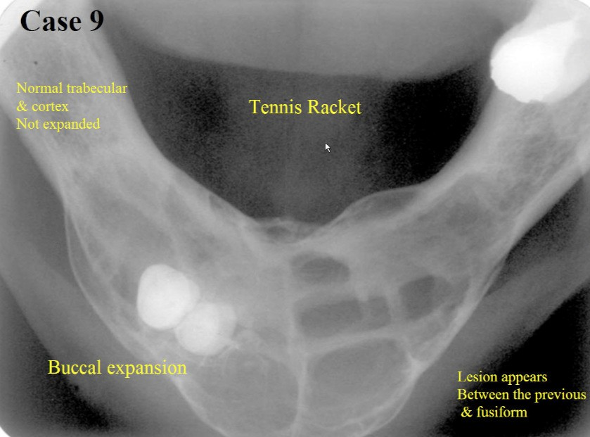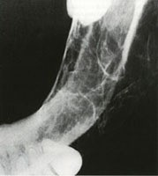

## Nasopalatine Duct Cyst

* An intraosseous developmental cyst of the midline of the anterior palate, derived from the islands of epithelium remaining after closure of the embryonic nasopalatine duct.

|  |  |
| --- | --- |
| **Clinical Features** | * Arises from embryologic remnants of the nasopalatine duct * Presents in the midline of the maxilla * Fluctuant, painless swelling |
| **Radiographic Features** | |  |  | | --- | --- | | **Site** | Centered in the maxillary midline within the nasopalatine foramen or canal | | **Shape** | Well defined corticated border, round or ovoid in shape   * Anterior nasal spine may be superimposed giving it a heart shape | | **Size** |  | | **Shade** | RL | | **Surroundings** | May expand the labial or palatal cortices of the maxilla  Adjacent teeth   * May displace roots so they diverge * Root resorption is possible | | **Density** |  | | **Displacement** | May displace the floor of the nasal fossa superiorly | | **Diameter** |  | |
| **Differential Dx** | PRIO -> Check to ensure the PDL is intact and separate from this lesion |
| **Tx** | Enucleate |

# Pseudocysts

## Simple Bone Cyst (Traumatic Bone Cyst)

* Asymptomatic intraosseous empty cavity of young patients located primarily within the mandible, lined by a thin loose connective tissue membrane and is adequately treated when blood enters the space during an intraosseous biopsy.

|  |  |
| --- | --- |
| **Clinical Features** | * Commonly in children and teeths * Usually asymptomatic * Primarily in the Mandible * Associated teeth are vital |
| **Radiographic Features** | |  |  | | --- | --- | | **Site** | Almost all are in the mandible -> most common in the posterior | | **Shape** | Well defined, delicately (sometimes not visible) corticated border   * Scallops between roots and teeth | | **Size** |  | | **Shade** | RL | | **Surroundings** | May expand the bone if large, otherwise they prefer to scallop along the inside of the bone  Adjacent teeth   * Usually no effect, Lamina dura is usually intact | | **Density** |  | | **Displacement** |  | | **Diameter** |  | |
| **Differential Dx** | Aneurysmal Bone Cyst  Lateral Periodontal Cyst  Odontogenic Myxoma  Unicystic Ameloblastoma  Radicular Cyst  KCOT  Central Giant Cell Granuloma |
| **Tx** | Monitor |

## Lingual Bone Defect (Stafne Defect)

A developmental concavity of the lingual cortex of the mandible, usually in the third molar area, caused by overextension of an accessory lateral lobe of the submandibular gland, and has the radiographic appearance of a well-circumscribed cystic lesion within the bone, usually below the inferior alveolar canal.

|  |  |
| --- | --- |
| **Clinical Features** | * Anatomic indentation of the posterior lingual mandible * Always under the IAN Canal * Asymptomatic * Found later in life (5th decade) -> So not associated with mandibular fracture really |
| **Radiographic Features** | |  |  | | --- | --- | | **Site** | All in the mandible, inferior to the IAN canal | | **Shape** | Well defined with a corticated margin   * Margin might be continuous with lingual cortical plate | | **Size** |  | | **Shade** | Completely RL | | **Surroundings** | Thinning of the lingual cortex, or complete erosion of the lingual cortex  Adjacent teeth   * No issues | |
| **Differential Dx** |  |
| **Tx** | No Tx |

## Periapical Radiolucency of Inflammatory Origin (PRIO)

A progression of an acute pulpitis in which exudate extends into the adjacent soft and hard tissues.

Radiographic term that includes 3 Dx:

* Periapical granuloma
* Cyst
* Abscess

|  |  |  |  |  |  |  |  |  |  |  |  |  |  |  |  |  |  |
| --- | --- | --- | --- | --- | --- | --- | --- | --- | --- | --- | --- | --- | --- | --- | --- | --- | --- |
| **Radiographic Features** | |  |  | | --- | --- | | **Site** | Centered on carious/necrotic tooth | | **Shape** | Unilocular with a poorly defined border | | **Size** |  | | **Shade** | RL | | **Surroundings** | Significant widening of the PDL | | **Density** |  | | **Displacement** |  | | **Diameter** |  | |
| **Differential Dx** |  |
| **Tx** |  |

# Various Radiographs

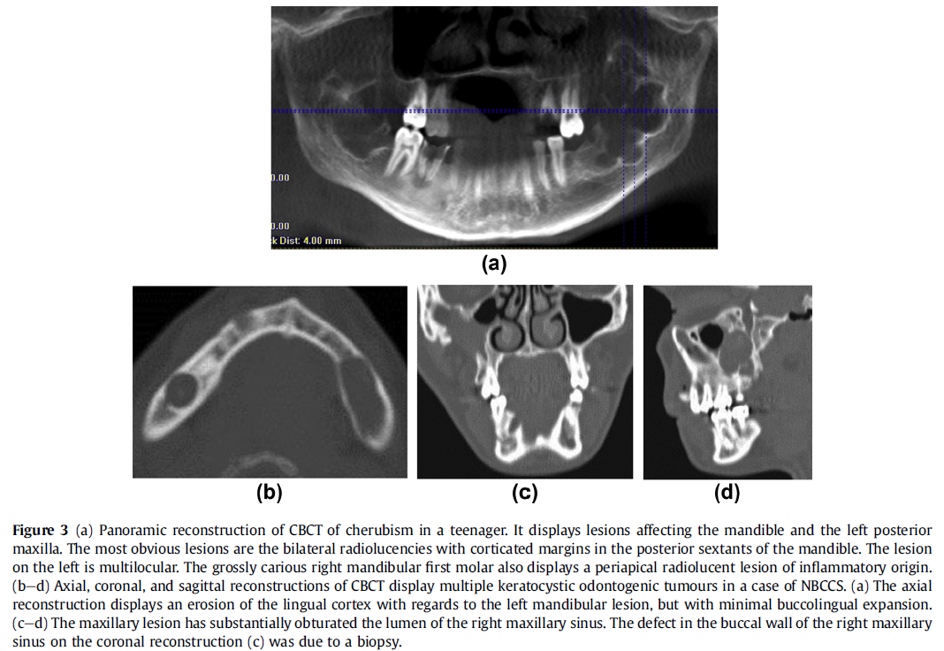Cherubism

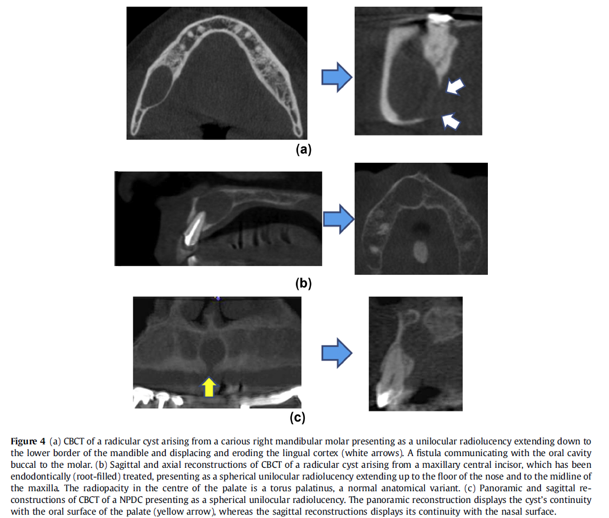

Radicular Cyst (A and B)

NPDC (C)

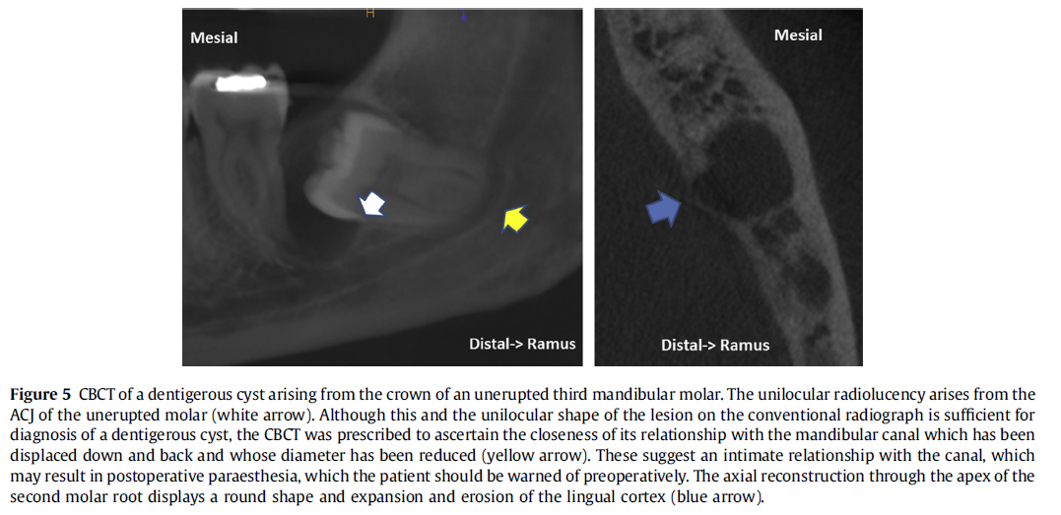

Dentigerous Cyst

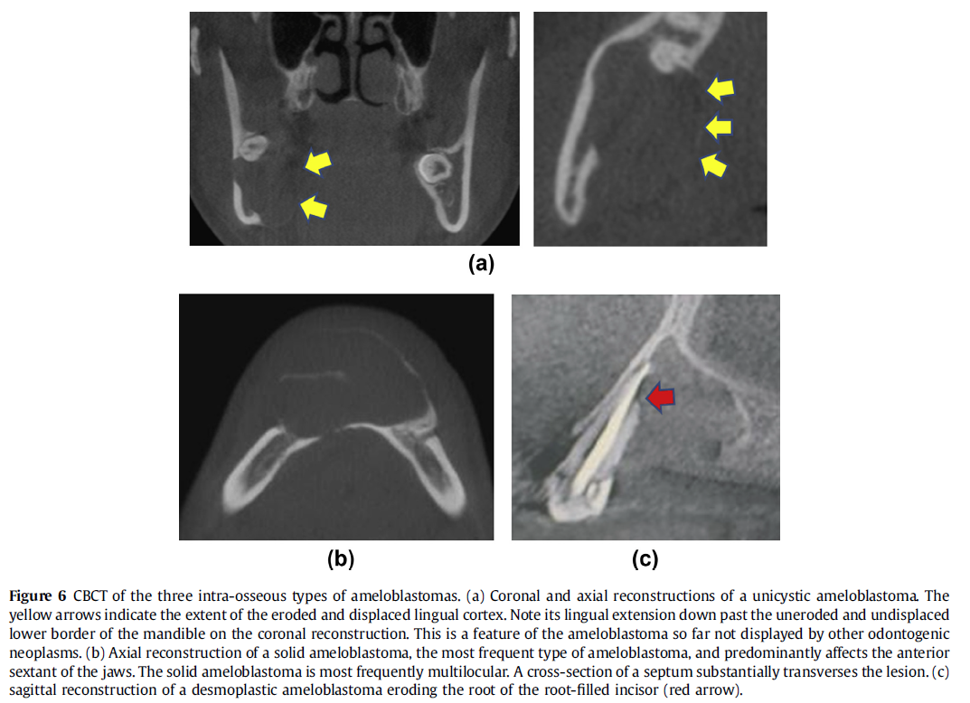

A: Unicystic Ameloblastoma

B: Solid Ameloblastoma

C: Desmoplastic Ameloblastoma

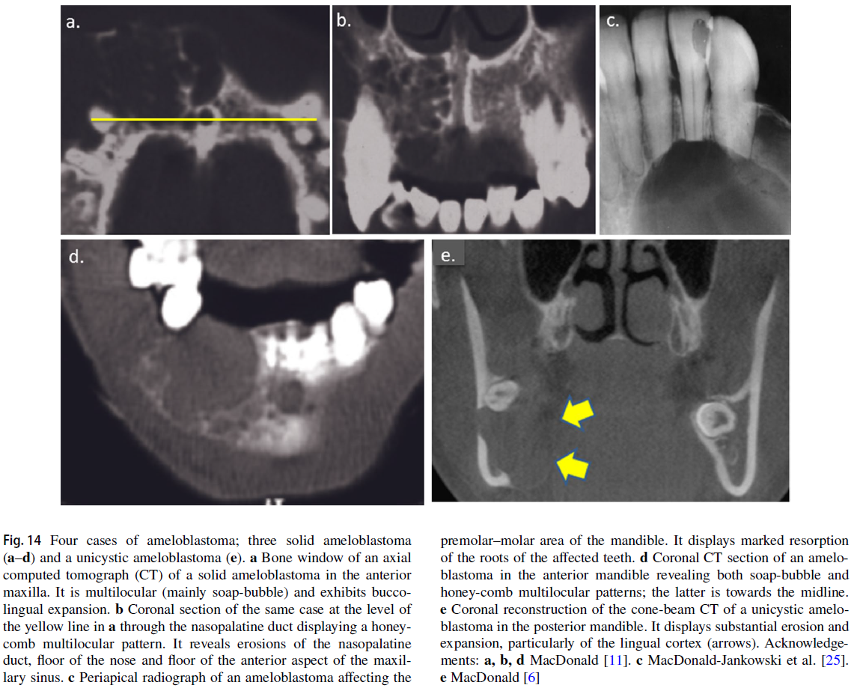

A-D: Solid Ameloblastoma

E: Unicystic Ameloblastoma

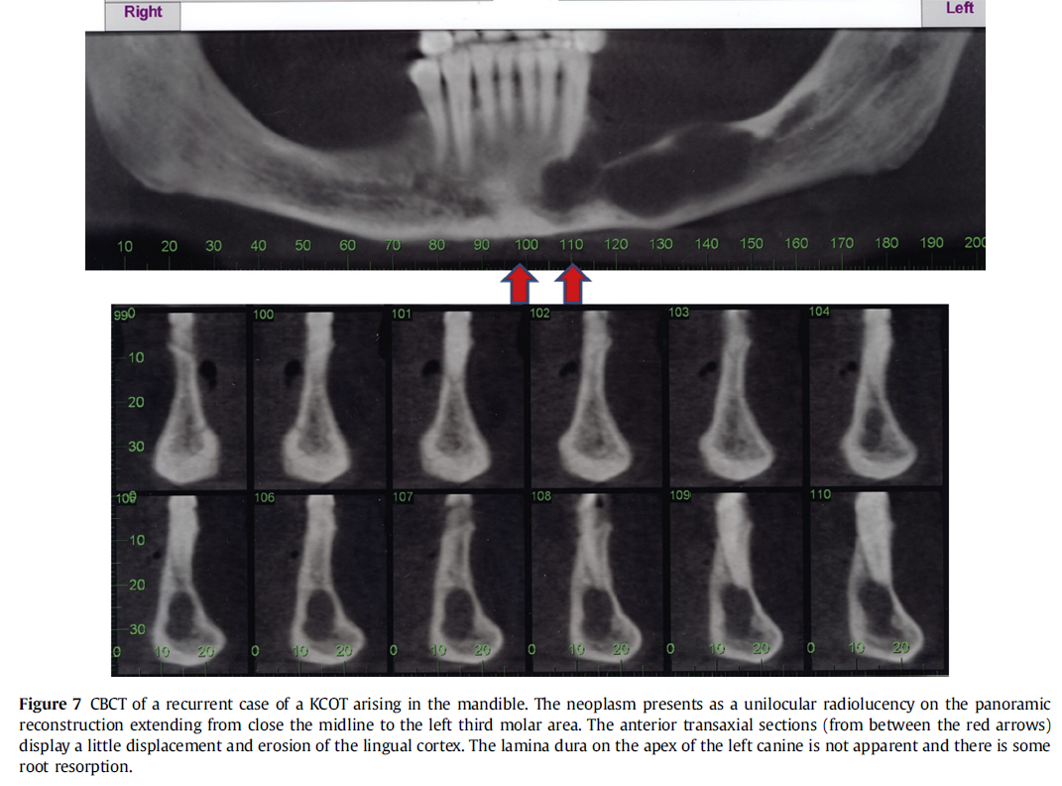

KCOT

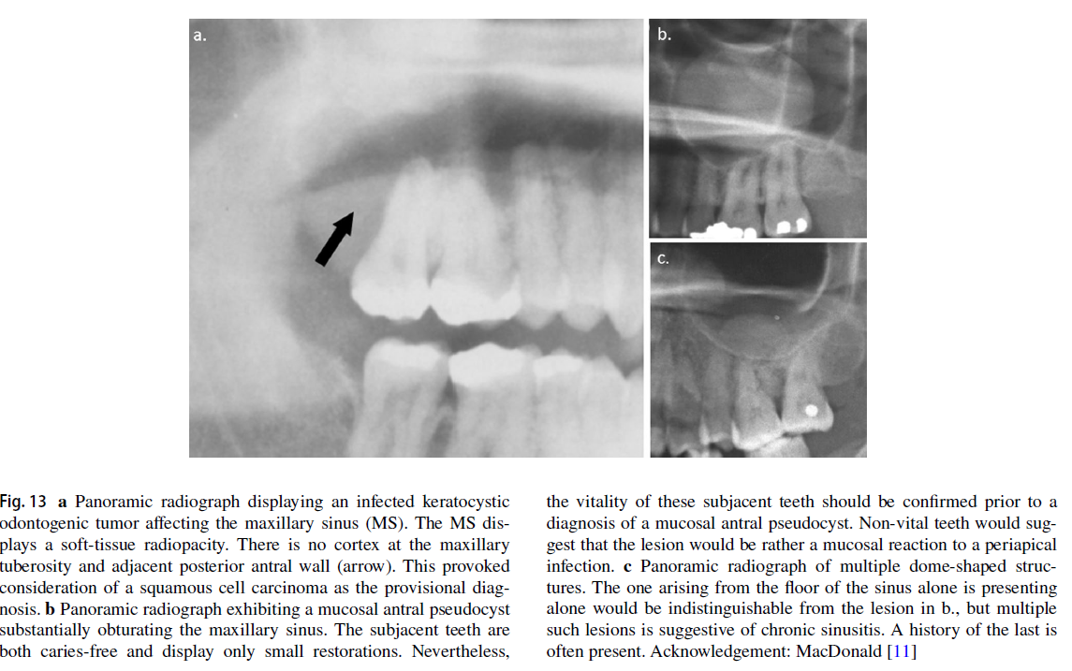

KCOT

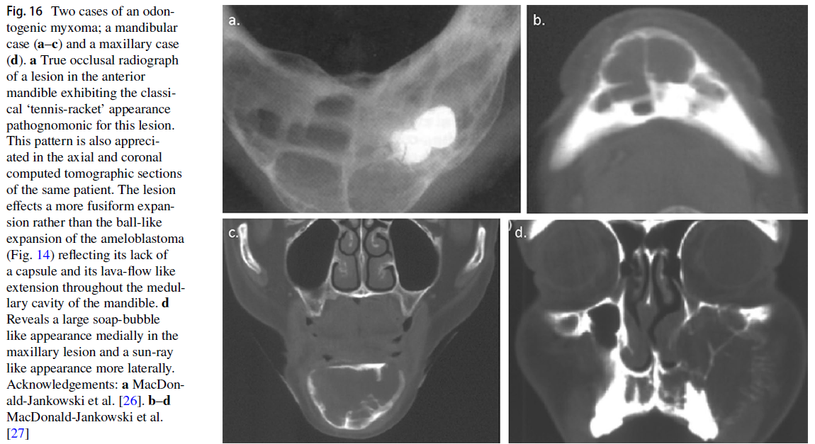

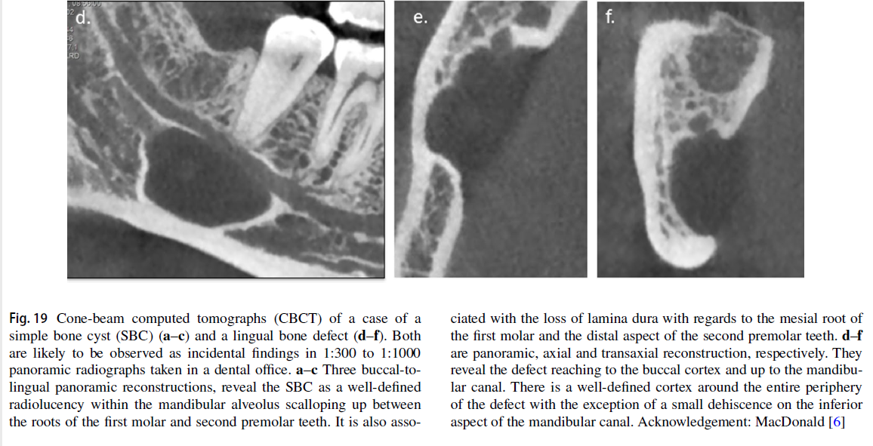Odontogenic Myxoma

Lingual Bone Defect

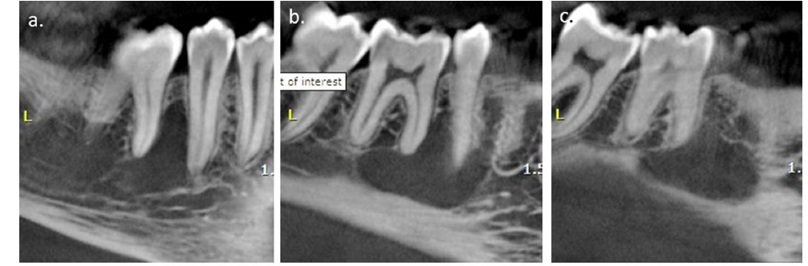

Simple Bone Cyst

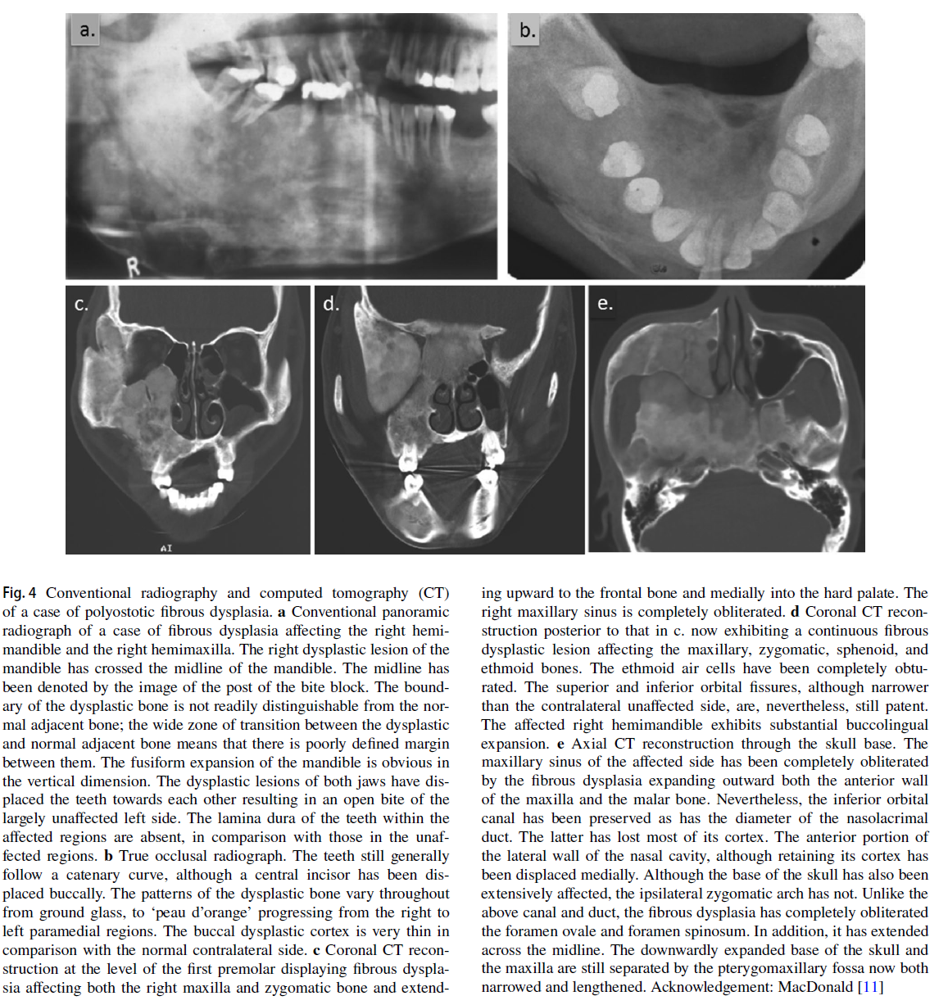

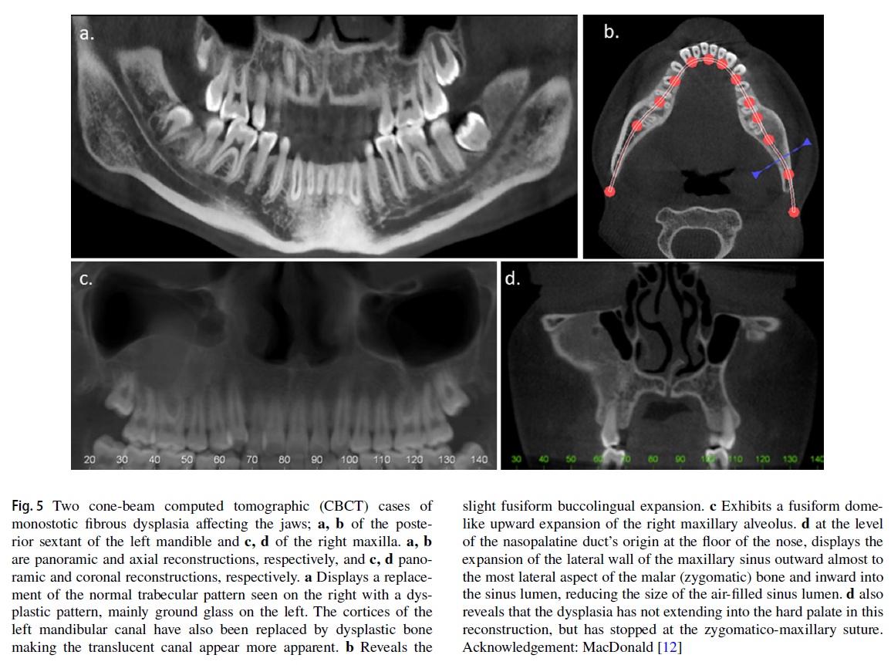Fibrous Dysplasia (Polyostotic)

Fibrous Dysplasia (Monostotic)

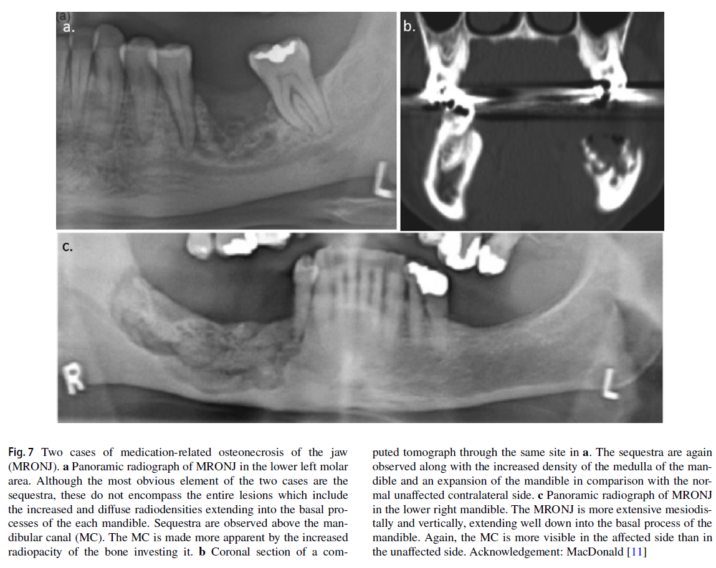

MRONJ

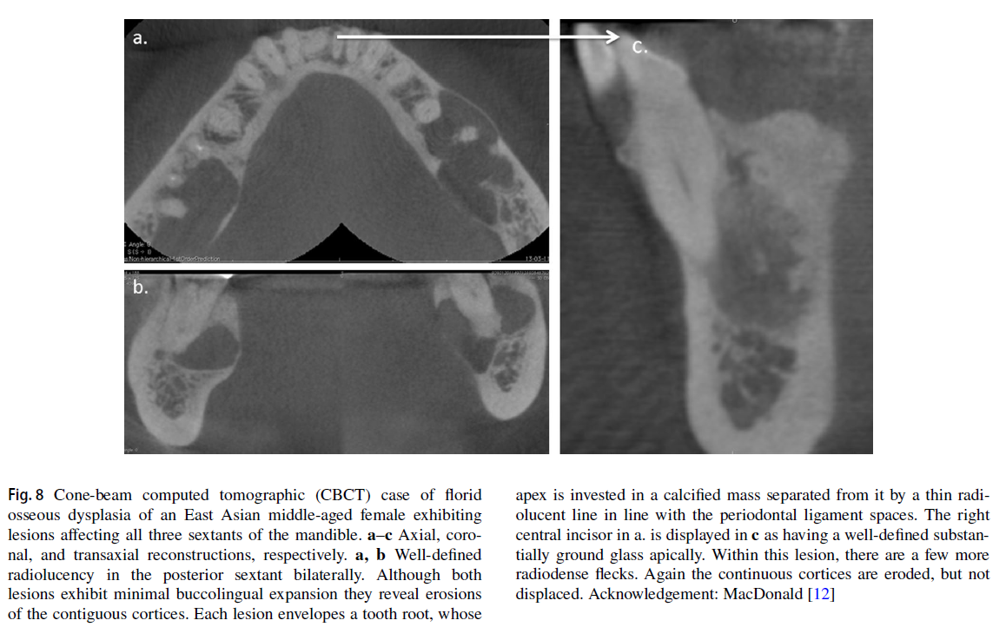

Florid Osseous Dysplasia

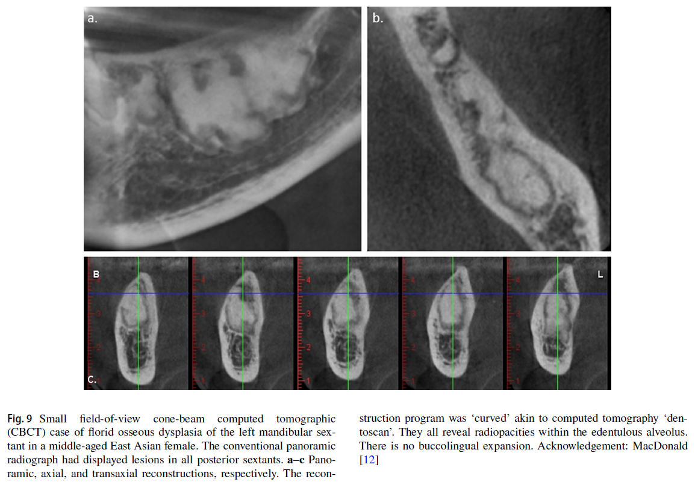

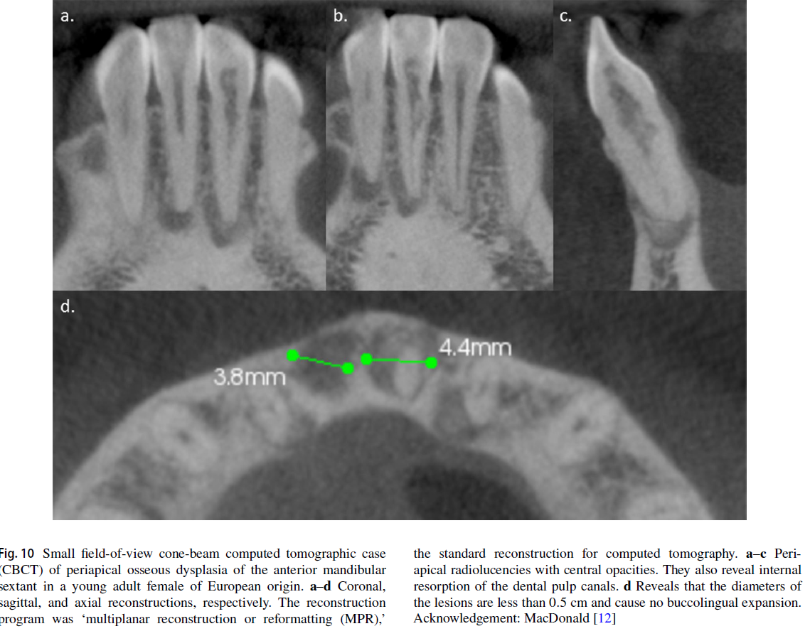

Periapical Osseous Dysplasia

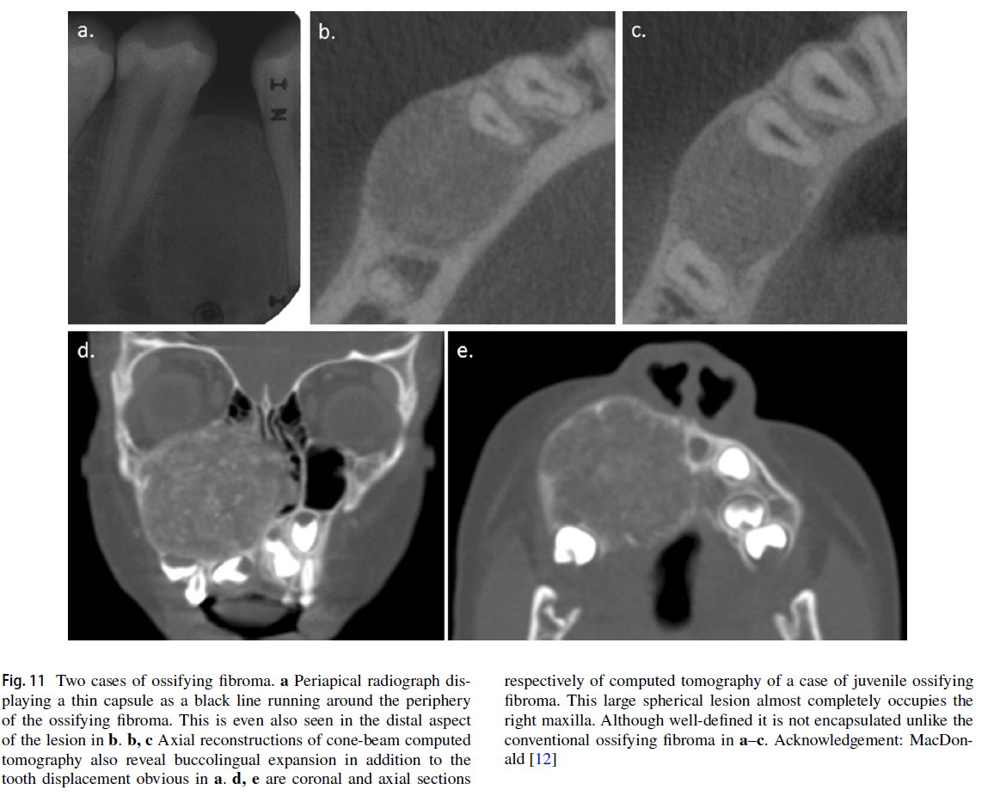

Ossifying Fibroma

# Differential Diagnosis Flowcharts

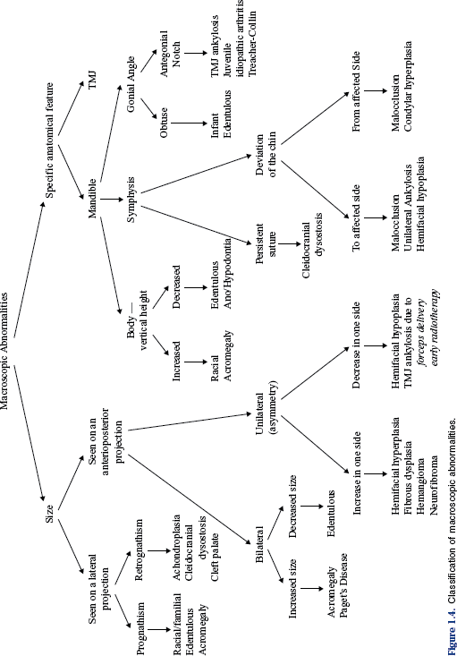

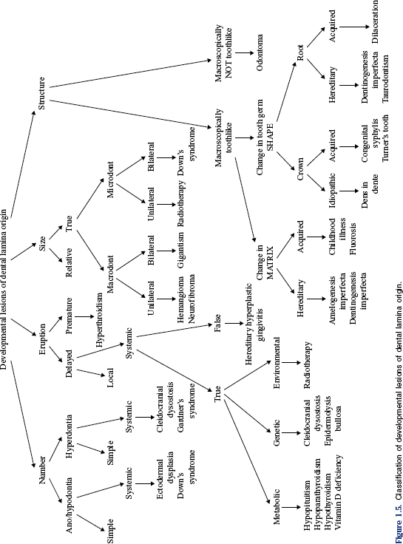

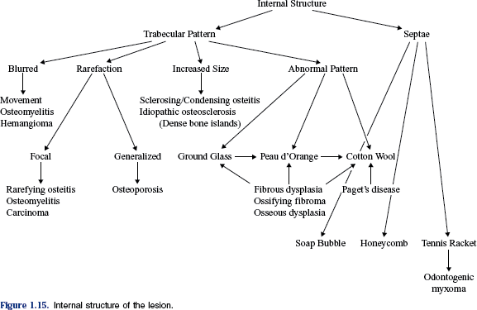

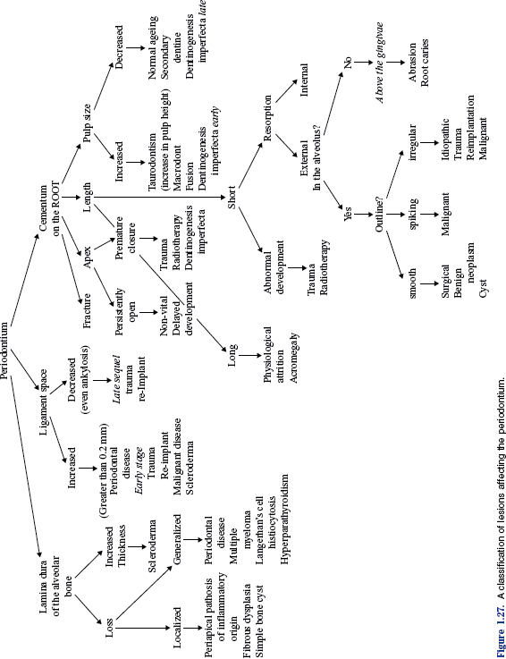

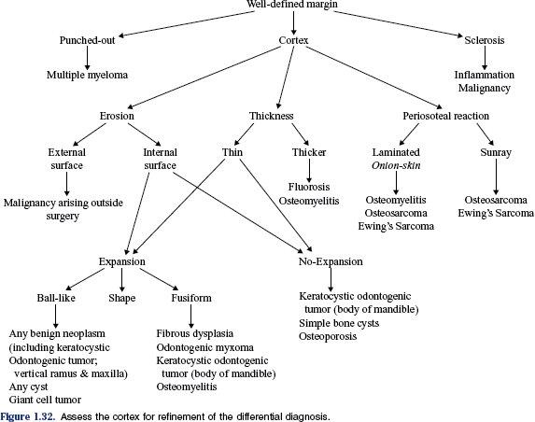

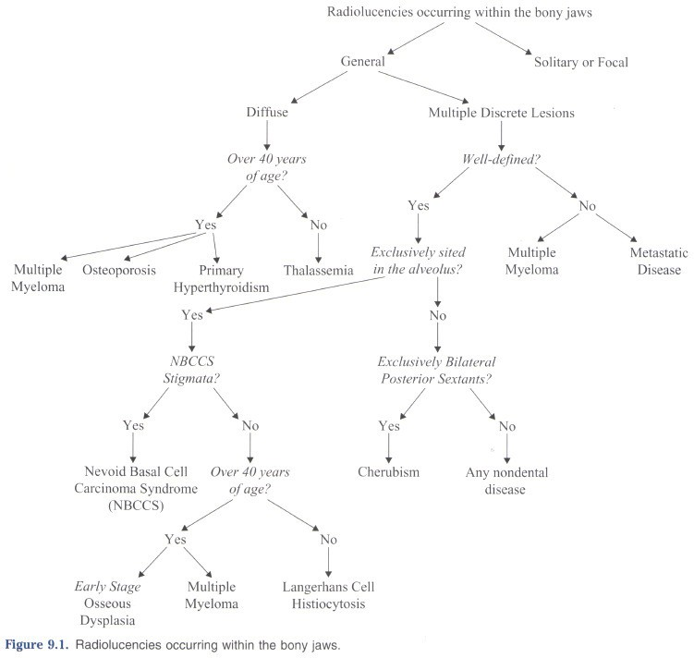

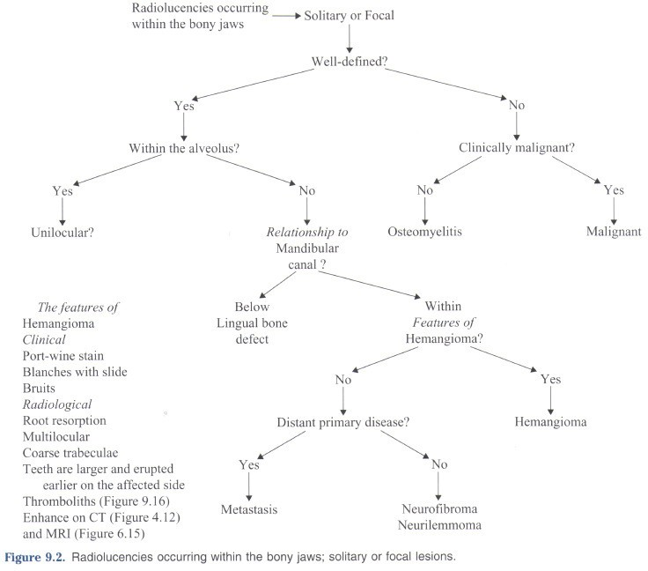

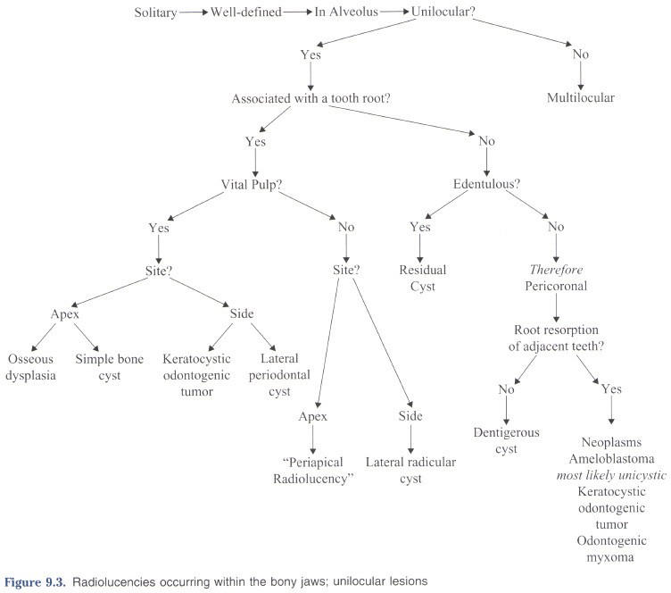

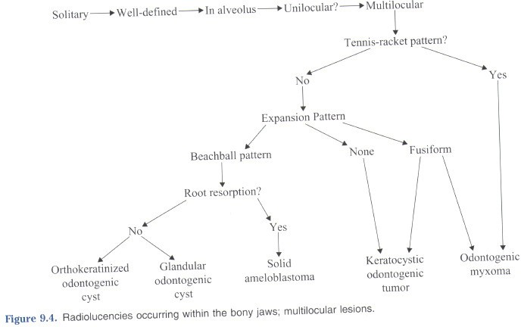

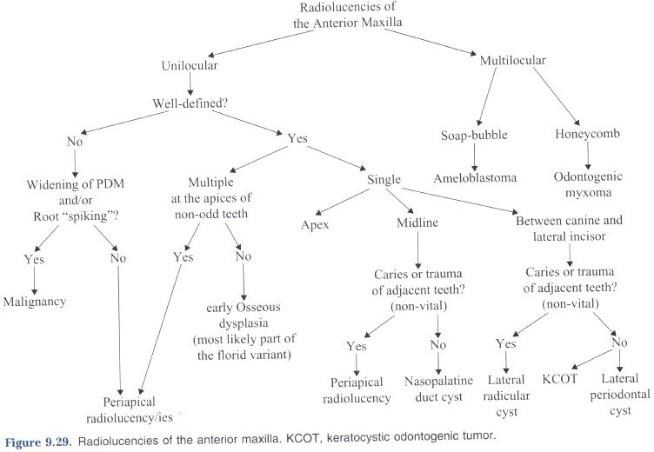

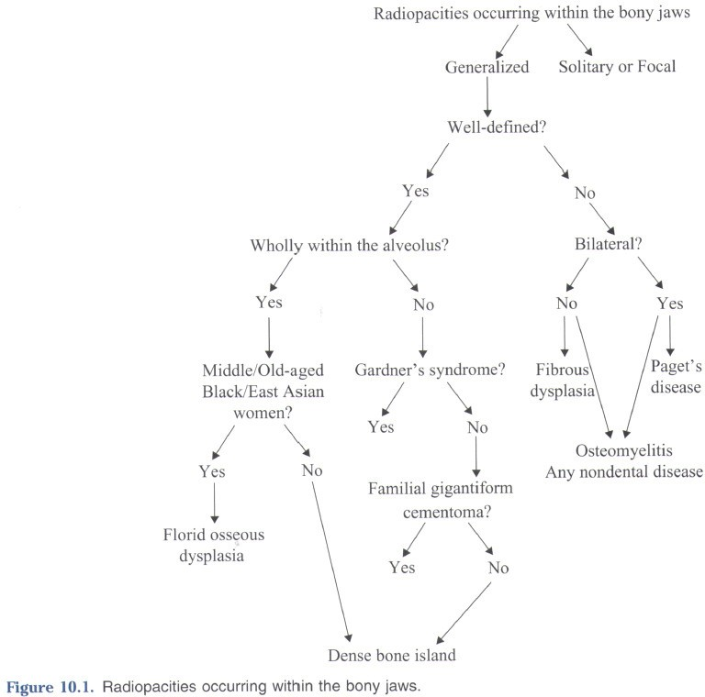

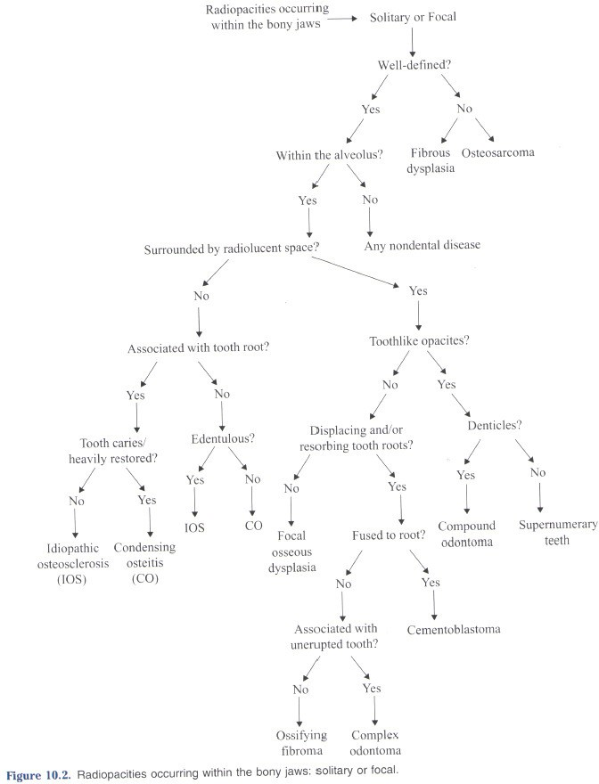

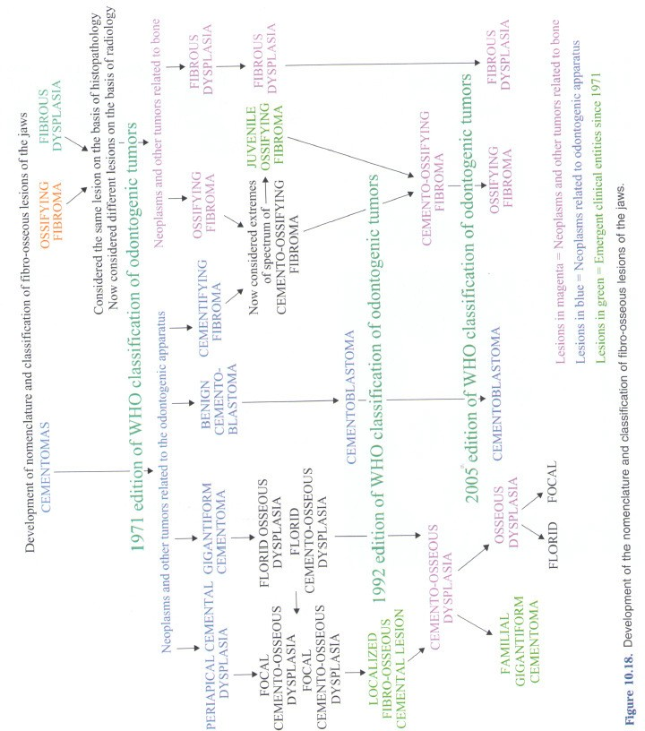

# A Very Large Table

|  |  |  |  |  |  |  |  |  |  |
| --- | --- | --- | --- | --- | --- | --- | --- | --- | --- |
| **Lesion** | **Shade** | **Shape** | **Site** | **size** | **surroundings** | **Diameter** | **density** | **displacement** | **DDX** |
| Fibrous displasia (McCune - Albright syndrome/) | Variable – Mostly Radiopaque (more trabeculae) | Fusiform (spindle shaped), ground glass, peau d’orange, finger print* (swirling pattern), cotton  wool | Mx>Md Polystotic / monostotic | Variable, Define boundari es,  and in mm | Poorly defined margins | Decrease Mx antrum, lower border of mandible | Lamina dura lost (PDL space wider), Occasional hypercementosis of root | – Mx antrum: keeps shape*  - IAN canal superiorly | 1. Paget’s disease (b/c similar bone pattern and expansion), 2. Osteomylitis (b/c jaw enlargement and new bone) |
| Ossifying Fibroma, COF | mixed | Ball-like B-L expansion | Md – premolar/molar sup to IAN |  | Well defined, encapsulated, Rlucent line separates it from surrounding |  | Resorption of teeth and lamina dura, Mx antrum (grow into and replace) | Teeth, Mx antrum, IAN, cortical plate (remains intact) | 1. Fibrous dysplasia (similar irregular trabelulae, cotton or flocculent) 2. juvenile ossifying fibroma 3. Periapical Cementodysplasia? 4. Giant Cell Granuloma (internal calcifications similar) |
| Giant Cell Granuloma/Tumor (or Central Giant Cell Lesion | Radiopaque | Ground glass, multilocular, if granular wispy septa* | Md:Mx = 2:1  1st 2 Decades ant to 1st molar Md or cuspid in Mx, Older more posterior |  | 66% Poorly defined malignancy often Mx, Md well defined |  | Resorption teeth, lamina dura missing | Displace teeth, IAN inferiorly, Expands cortical plate Mx & Md (undulating),can destroy Mx plate  = malignant appearance | 1. FOL/COF (ground glass) 2. Ameloblastoma/odontogenic myxoma (b/c multilocular) |
| COD – Focal PCD | 3 phases;  Early – Rlucent, Mixed – mixed, Mature – Rpaque center & Rlucent boarder often  continuous with PDL* | Round, oval | Ant. Md apex tooth; Young solitary, Midle age unilateral,  Old bilateral |  | Well defined |  | No resorption Lamina Dura lost | No  Seldom >1cm, Can displace jaw and antrum | 1. (mature) benign cementoblastoma 2. periapical abscess/cyst 3. periapical granuloma |
| COD - Florid |  |  | PCD in 3-4 quads or extensive in one jaw |  |  |  |  |  | 1. Paget’s (cotton wool, hypercementosis) 2. chronic diffuse sclerosing osteomyelitis (cementum like masses) 3. fibrous dysplasia 4. cementifying/ossifying fibroma |
| Odontoma | Radiopaque = or > adjacent tooth | Compound (bag of teeth)* | Complex – Md 1st & 2nd molar area, Compund – ant Mx  – crown of unerupted canine | Complex  – large Compou nd – size of tooth | Well defined, smooth or irregular, cortical boarder |  |  | Prevent eruption of teeth, Lg Complex expand jaw | 1. COF (odontoma more radiopaque) 2. PCD (pcd more centered) 3. cementoblastoma |
| Cementoblastoma | Radiopaque | Wheel spoke pattern*, Round, B-L expansion | Md 1st Premolar – Molar,  Fused w/ roots, |  | Well defined, Rlucent Halo just inside cortical  boarded |  | External root resorption, Obscures PDL | Expansion of cortical plates, Displace teeth | 1. Solitary PCD 2. COD (Rlucent band) 3. DBI |

|  |  |  |  |  |  |  |  |  |  |
| --- | --- | --- | --- | --- | --- | --- | --- | --- | --- |
| **Lesion** | **Shade** | **Shape** | **Site** | **size** | **surroundings** | **Diameter** | **density** | **displacement** | **DDX** |
| Garnder’s Syndrome (multiple osteomas) | Uniformly Rpaque | bony trabeculae | Angle of Md (look for multiple impacted supernumerary teeth) |  | well-defined |  |  |  |  |
| Periapical Inflamatory Lesion PA Abcess (acute) Granuloma (chronic) Cyst(after granuloma) | RadioLucent | Unilocular, spherical, | Tooth apex (assoc. w/ carious/resto’d teeth) |  | Abcess = Ill defined Granuloma/Cy st have capsul |  | Widening of PDL, can have more bone formation = PA sclerosing ostitis, bone resorption = PA rarefying ostitis | Abcess: Often > 1.5cm expansive and displacing*, Granuloma: Often < 1.5cm non-displacing, in chronic - external root resorption, may destroy cortical  boundaries | 1. PCD (early) 2. DBI (for sclerosing ostitis) |
| Residual Cyst |  |  | PA Cyst minus the tooth |  |  |  |  |  |  |
| Lateral Periodontal Cyst | RLucent | Round/oval | Md 2nd premolar – lateral incisor, Later root surface | < 1cm | Well defined, prominent cortical boundary |  |  | Resorbs Lamina dura, Lg cysts can cause expansion | 1. Small KOT (b/c location & x- ray appearance) 2. Mental foramen (location) 3. Radicular Cyst |
| Dentigerous Cyst | RLucent | unilocular | 3rm molars and Mx Canines, w/n 1mm of CEJ* & around crown of unerupted or supernumery teeth (mesiodens Mx) |  | Well Circumscribed, |  | No root resorption but can resorb adjacent teeth | Displaces affected tooth apically, expands corical bone, displaces teeth & IAN, grows into antrum, | 1. hyperplastic follicle 2. OKC ( not at CEJ, doesn’t resorb/expand as much) 3. ameloblastoma – unicystic (early stage) 4. Radicular cyst at apex of primary tooth (looks like DC of crown of 2ndary) |
| Simple Bone Cyst (traumatic BC) | Rlucent | Unilocular (scalloped), can have septae | Post. Md |  | Variable boarder |  | Lost lamina dura, no tooth resorption | Generally no expansion of cortex (longitudinal growth) | 1. KOT (b/c longitudinal growth w/ little expansion & scalloped boarder) 2. Dentigerous cyst (if associated with impacted tooth) |
| Odontogenic Keratocyst (OKC) (KOT) |  | Round/oval or scalloped, uni/multilocular | 80% Md, 60% 3rd  molar, Epicenter sup. To IAN |  | Well Defined |  | Can resorb roots | Little B/L expansion, Displace IAN inf., grow into antrum | 1. Dentigerous cyst (b/c pericoronal center) 2. Ameloblastoma (b/c multilocular and scalloped) 3. Odontogenic myxoma (b/c multilocular & mild expansion) 4. Simple bone cyst (b/c scalloped & minimal expansion) |

|  |  |  |  |  |  |  |  |  |  |
| --- | --- | --- | --- | --- | --- | --- | --- | --- | --- |
| **Lesion** | **Shade** | **Shape** | **Site** | **size** | **surroundings** | **Diameter** | **density** | **displacement** | **DDX** |
| Gorlin-Goltz Syndrome (multiple KOT) |  |  | multiple odontogenetic keratocysts in Md molar/premolar & Mx 3rd molar |  |  |  |  |  | 1. Cherubism 2. Multiple dentigous cysts |
| Ameloblastoma (Unicystic)  (also mentioned are polycystic & peripheral) | RLucent | unilocular (early) or multilocular (advanced): Soapbubble or honeycomb | Post Md, can be occlusal to tooth bud | Larger posterior  , smaller anterior | Well defined, corticated and sclerotic margins |  | Extensive Root Resorption** | tooth displacement, thinning of cortical plate & B/L expansion | 1. Dentigerous cyst – (b/c small unilocular if surround crown of unerupted) 2. OKT (b/c internal boney septae   – multilocular)   1. odontogenic myxomas (b/c of septa) 2. Giant Cell Granuloma (b/c Septae) 3. Ossifying Fibroma (b/c septae) |
| Odontogenic Myxoma | RLucent | 50% mutilocular  – Tennis Racquet**, fusiform expansion | Md premolar/molar |  | Poorer defined |  | Rare root resorption | Tendency for longitudinal growth (may get B/L exp with Lg lesion),  Displaces teeth | 1. Simple bone cyst (b/c scallops b/w roots of teeth) 2. Septae list |
| Dense Bone Island (5 or more think Gardner’s syndrome) | RPaque |  | Md premolar/molar, DBI vs SO:  DBI if not assoc. w/ tooth,  Or a non-carious, unrestored tooth; SO if carious, heavily resto’d tooth |  | Well defined, no capsule or margin |  | May cause root resorption (on vital tooth & self- limiting) if involving tooth |  | 1. Periapical Cemento Dysplasia (Rpaque) 2. Periapical sclerosing osteitis (if at apex) |
| Sclerosing Osteitis (response to PA inflammation) | RPaque |  | Premolar/molar, around tooth apex |  |  |  |  | No bone expansion | 1. DBI 2. Cementoblastoma (b/c Rpacity near root) |
| Stafne bone defect | RLucency | Round, ovoid, lobulated | Submandibular gland fossa, close to inf boarder of Md, below IAN* |  | Well Defined, dense sclerotic boarder, Thicker on superior  aspect* |  |  |  | Readily Differentiated  a. If rare and above IAN – other odontogenic lesion |
| Nasopalatine duct cyst | RLucent | Round or oval, may be heart shaped b/c of superimposition of anterior nasal  spine | Nasopalatine foramen or canal (b/w apex of 11- 21)* |  | Well defined, corticated |  | Occasional root resorption | Expand bone, displace teeth (centrals roots diverge), can displace floor of  nasal fossa | 1. Lg incisive foramen 2. Radicular cyst (only if cyst associated with central incisor apex b/c it’s asymmetric) |
| Stylohyoid complex | RPaque (seen on PAN) | Long tapering thin process  (thicker at base) | Mastoid process toward hyoid bone, |  |  |  |  |  |  |